Weekly Research Report Studio 5

Student name :Zihan Liu

Report date : 22/2/2024

What did you do this week?

**Mid-blocked PPT created and will have presentation on week 5 Friday.**

**Successfully completed the construction of the database by MSQL, creating a total of 12 tables to support the project's data needs.**

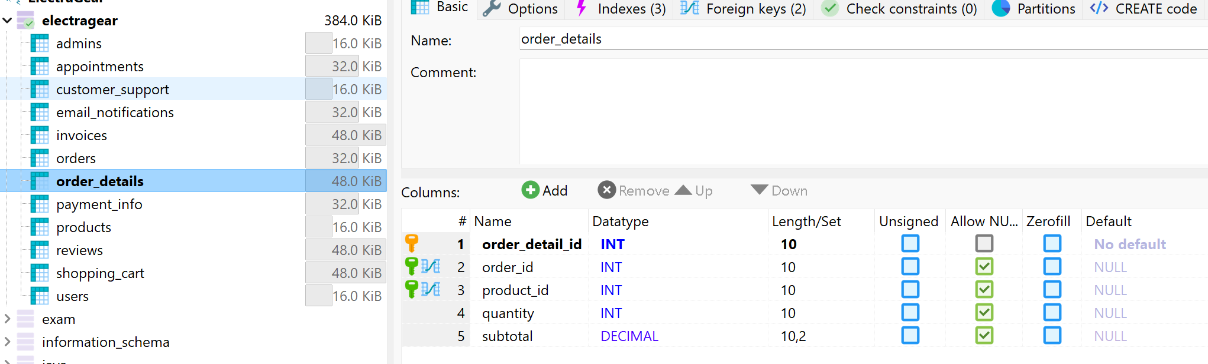

**Developed an Entity-Relationship Diagram (ERD) and Enhanced Entity-Relationship Diagram (EERD imported) to visually represent the logical relationships between the database tables**

What are you planning to do next week?

*Design other pages by using Figma*

*Keep working on writing the requirement analysis report.*

*Keep updating the Trello dashboard.*

Do you need help with anything?

Any suggestion either technical or presentation